Assignment#3

1. Launch minikube cluster and execute the commands to test the pod, container with the kubectl commands

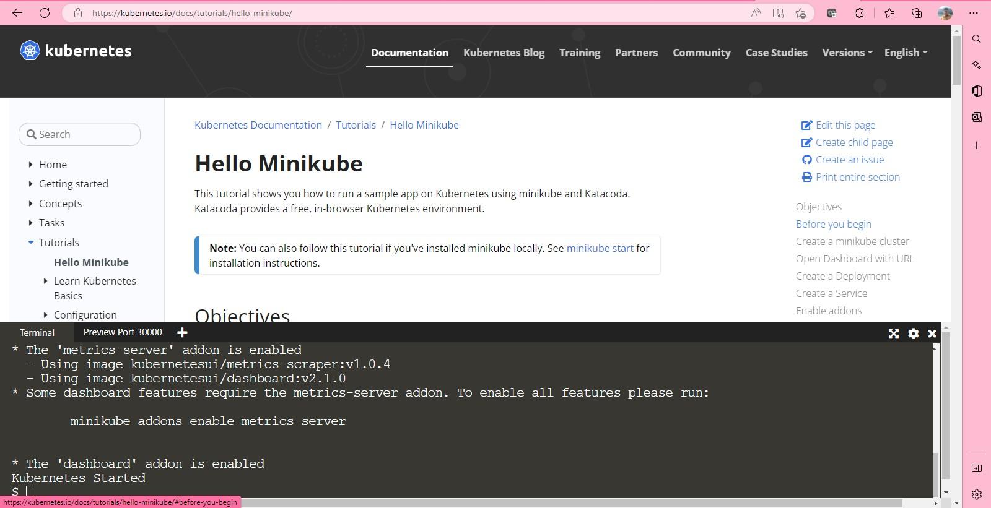

Command: minikube start

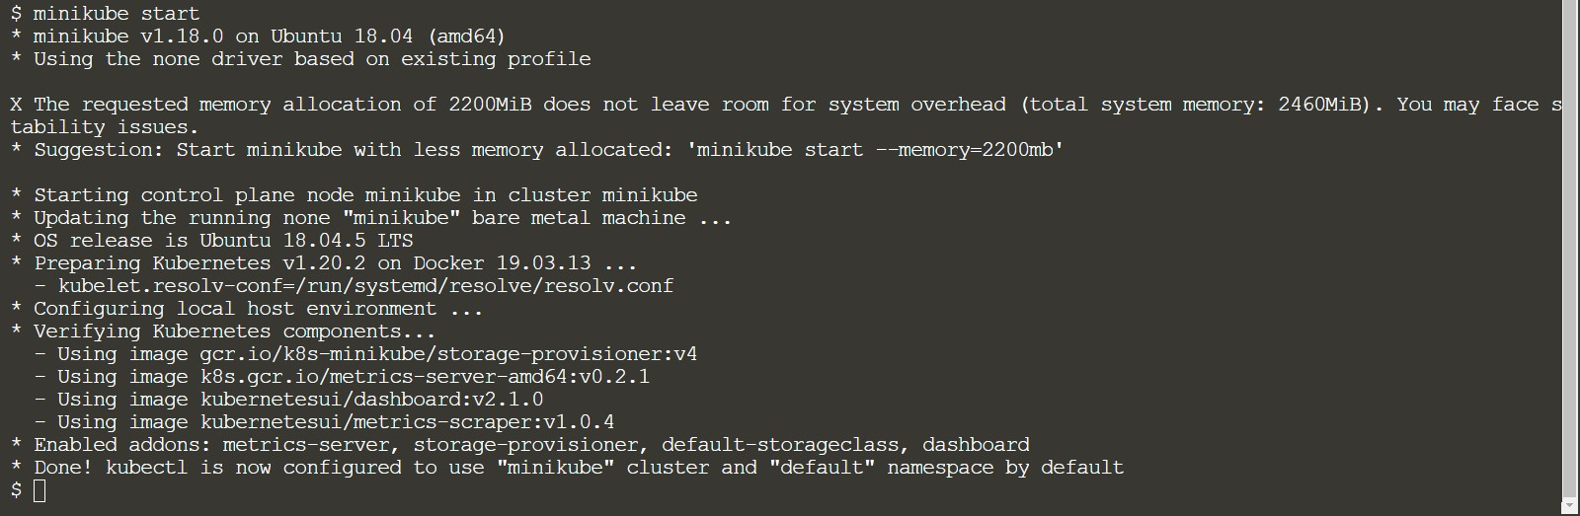

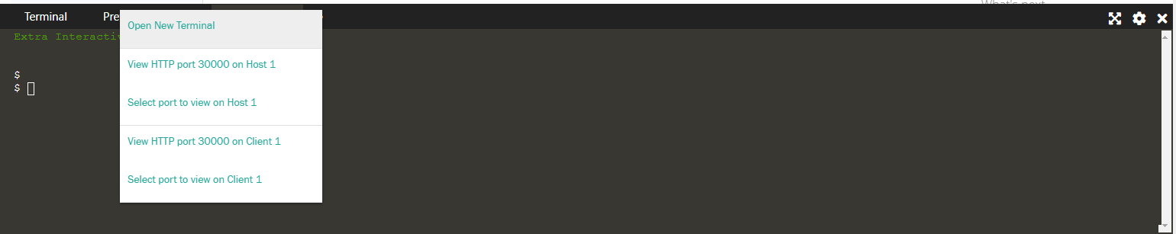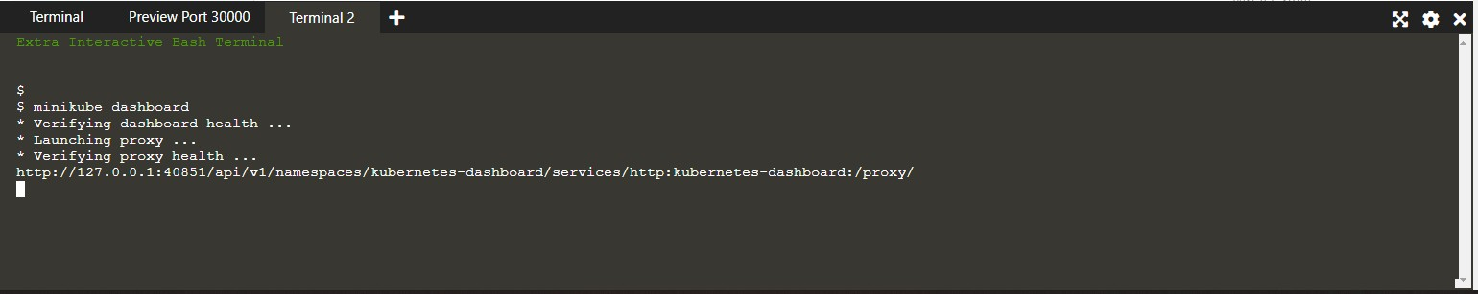

Minikube Dashboard

@ https://e91f0a45cb3645bd9b1425675ddfb7b4-167772171-30000-simbaO8.environments.katacoda.com/6/overview?namespace=default A* @ .

**kubernetes**



default

Service

* + Q Search + m

Cron Jobs Daemon Sete

Services —

Deploymerrts

Jobs

Name

Namespace

Labels

component: apiserver

Cluster IP

Internal Endpoints External Endpoints Created ?

kubernetes:443

Pods Replica Sets

Replication Controllers Stateful Sets

lngresses



@ kubernetes

Config and Storage Config Maps

Name

default

provider: kubernetes

Namespace

Labels

10.96.0.1

TCP

kubernetes:0 TCP

Created ?

7 minutes ago ;

Config and storage

default

7 minutes ago ;

Config Maps u

Persistent Volume Claims n



Storage Classes Cluster

Secrets

Name

Namespace LabelG

Type



Created 1’

**All Packages on Kubernetes GitHub repository:** registry.k8s.io/

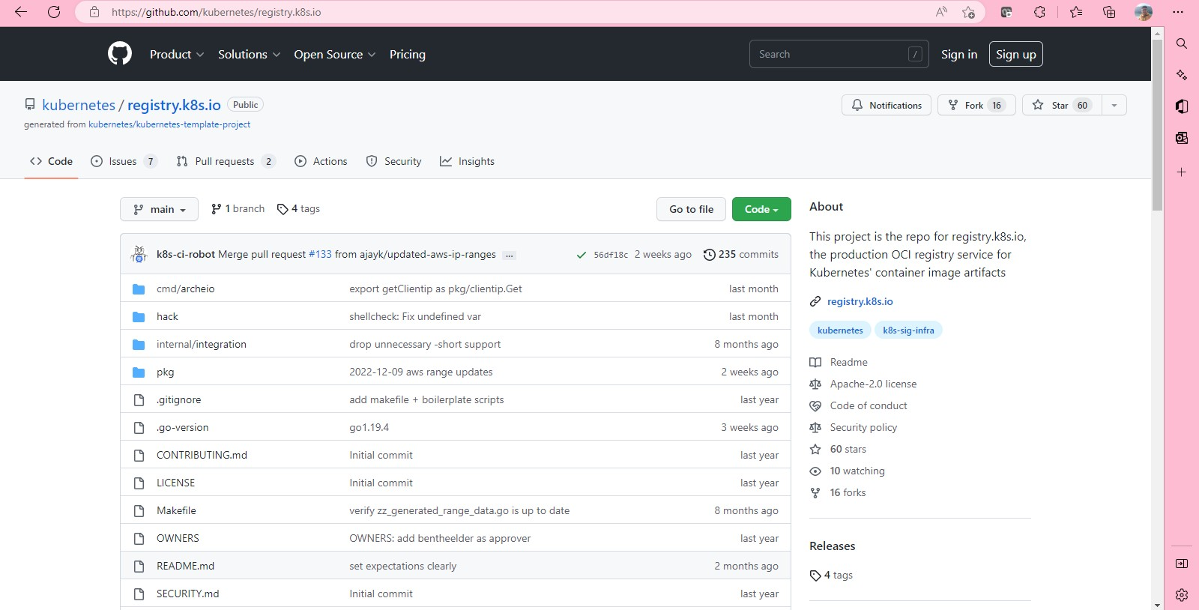

A Kubernetes Deployment checks on the health of your Pod and restarts the Pod's Container if it terminates.

Here 1 Pod=1 container

1) Use the kubectl create command to create a Deployment that manages a Pod. The Pod runs a Container based on the provided Docker image.

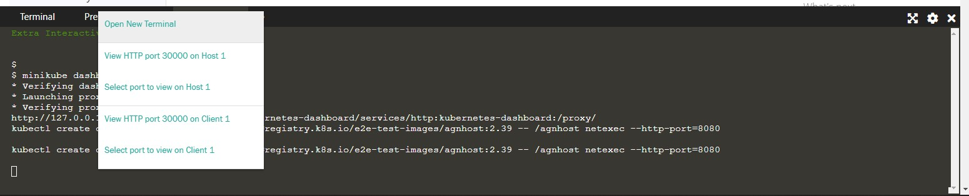

Creating a node, testing-node



A node created

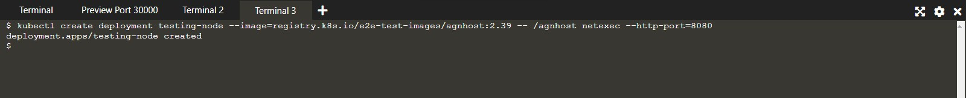

To Display Namespaces

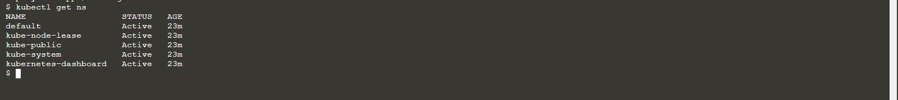

$ kubectl get ns

NAME STATUS AGE

default Active 23m kube-node-lease Active 23m kube-public Active 23m

kube-system Active 23m kubernetes-dashboard Active 23m

kubectl get all -n kube-system

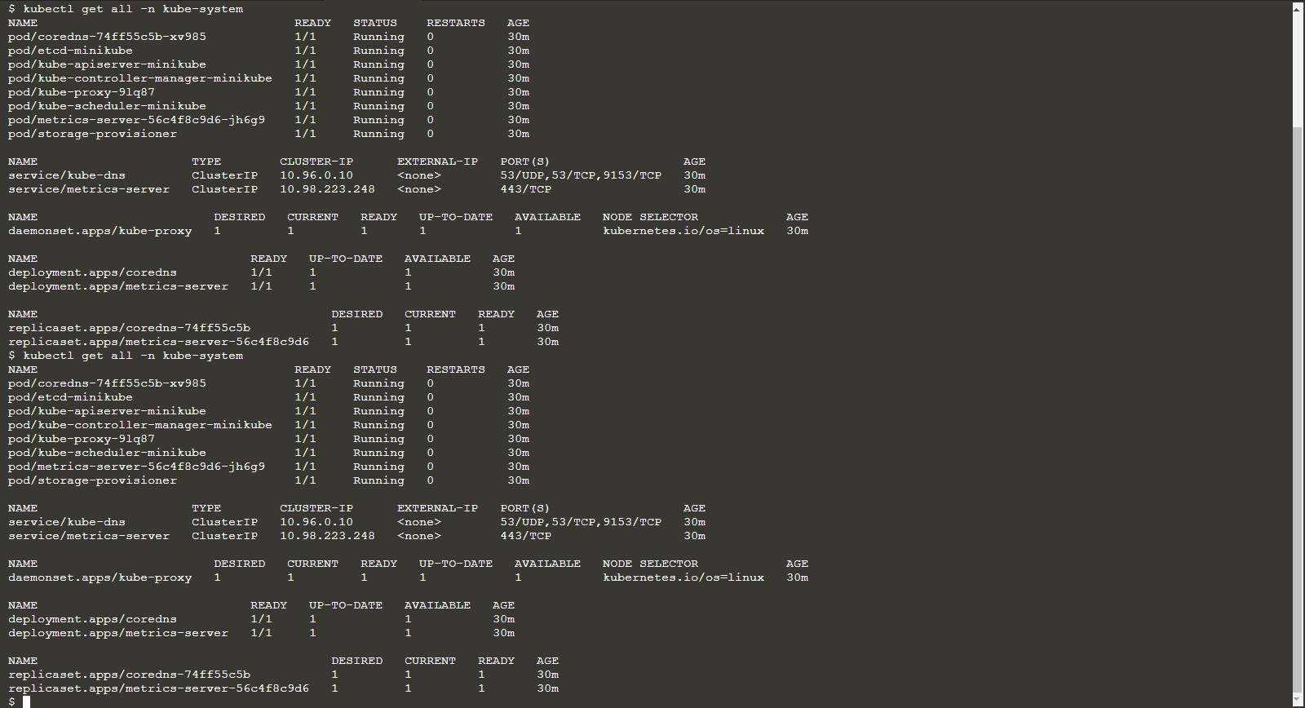

Now, creating test name space



Get all pods:

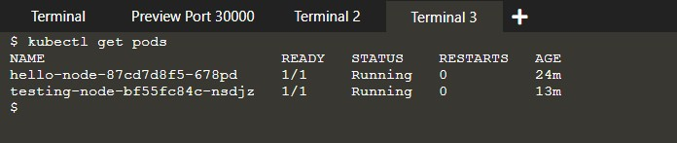Command: kubectl get pods

Two pods are getting. To get logs of Pods:

Command: kubectl logs [pod-name]

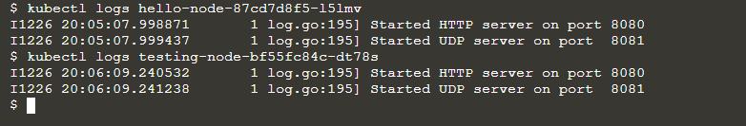

To get how many pods are deployed:

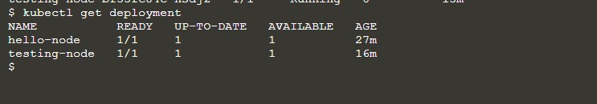

Now from Dashboard Pods Status:

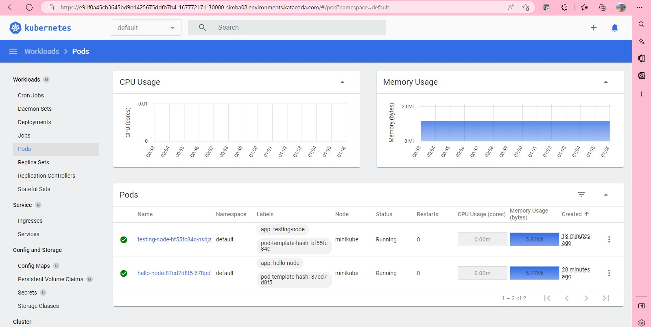

Thus, two pods are showing. Now Status about deployments:

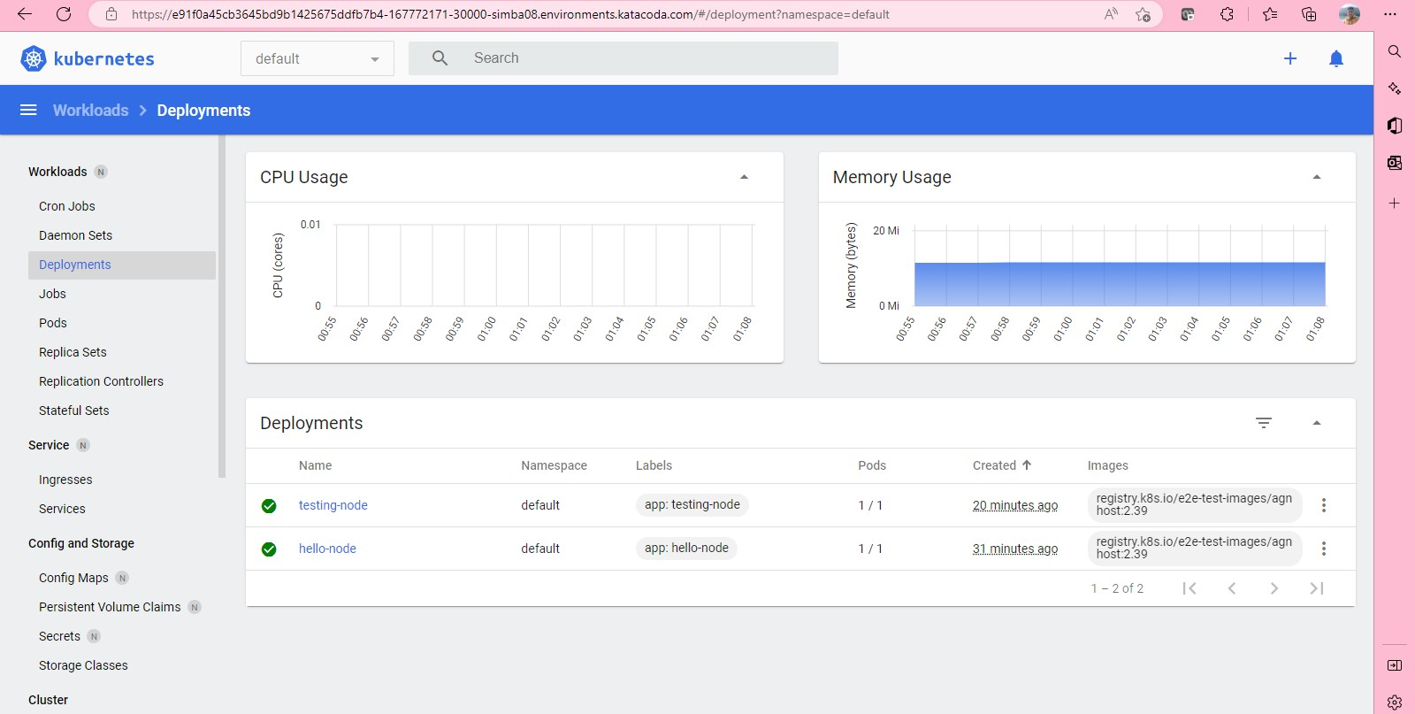

Now kubectl describe pods



Pre\'ien Port 30000

Termi nal 2

Termi na1 3 -{-

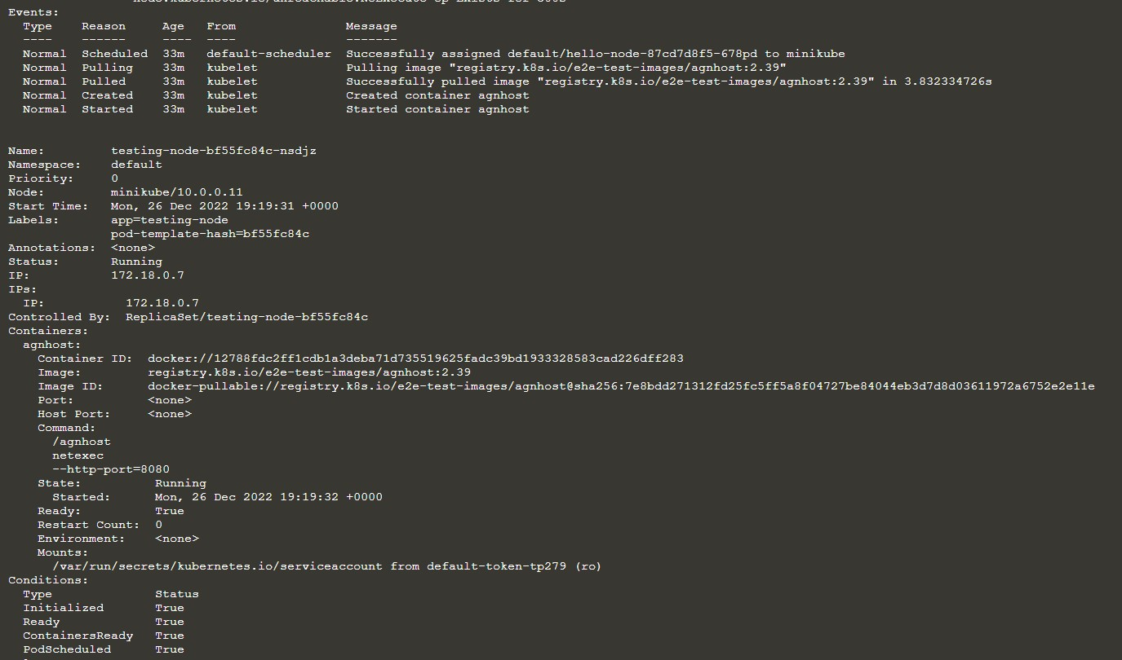

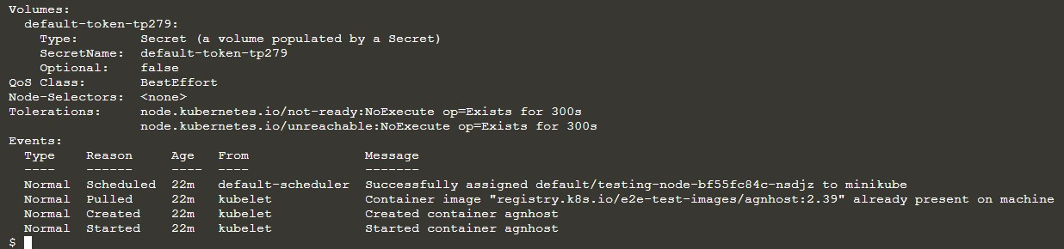

To get Nodes details:

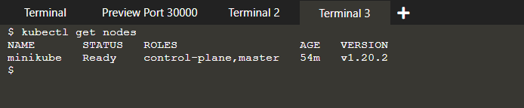

To Check Cluster Events: Commands: kubectl get events

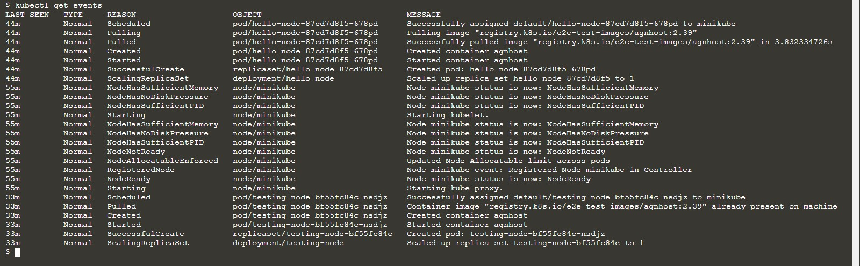

To check configurations:

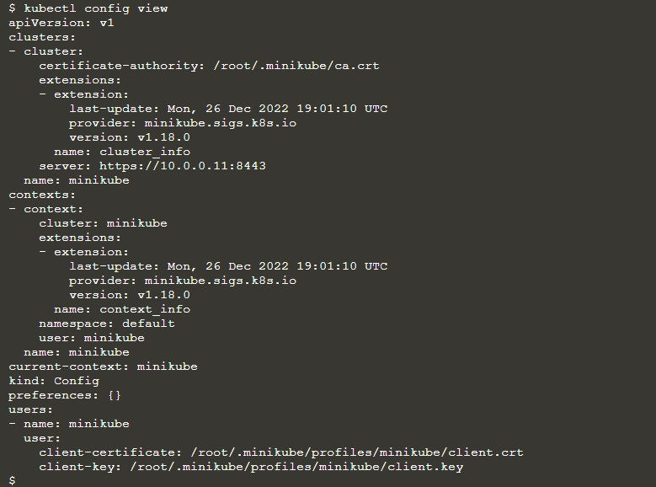

To check services by: kubectl get services

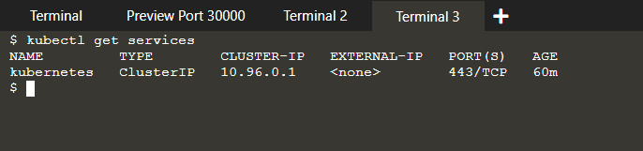

Pod to the public internet using the kubectl expose command:



To Check the created service:

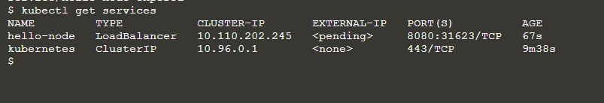

To Check Cluster info:

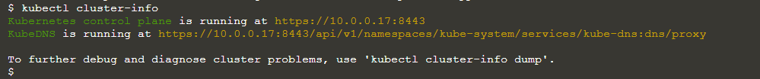

Checking Service of Specific node:

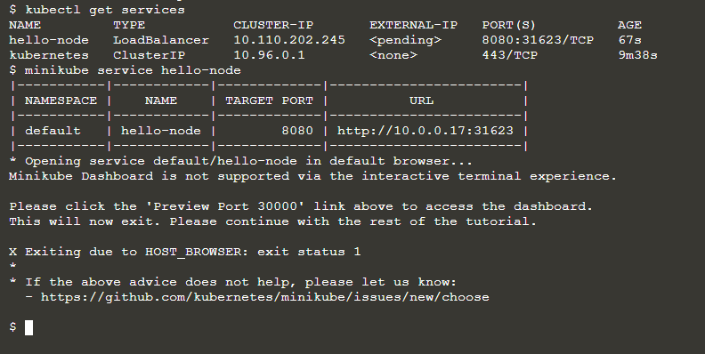

Now testing-node:

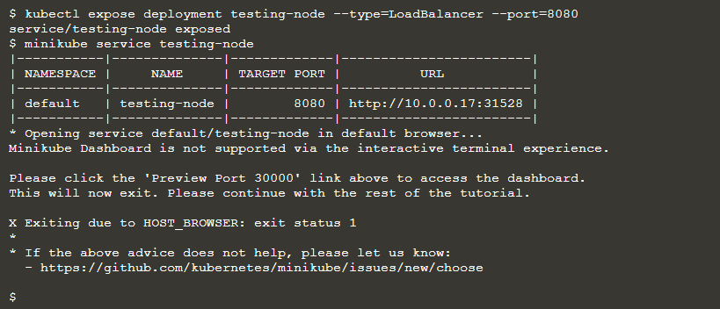

Now pods Status:

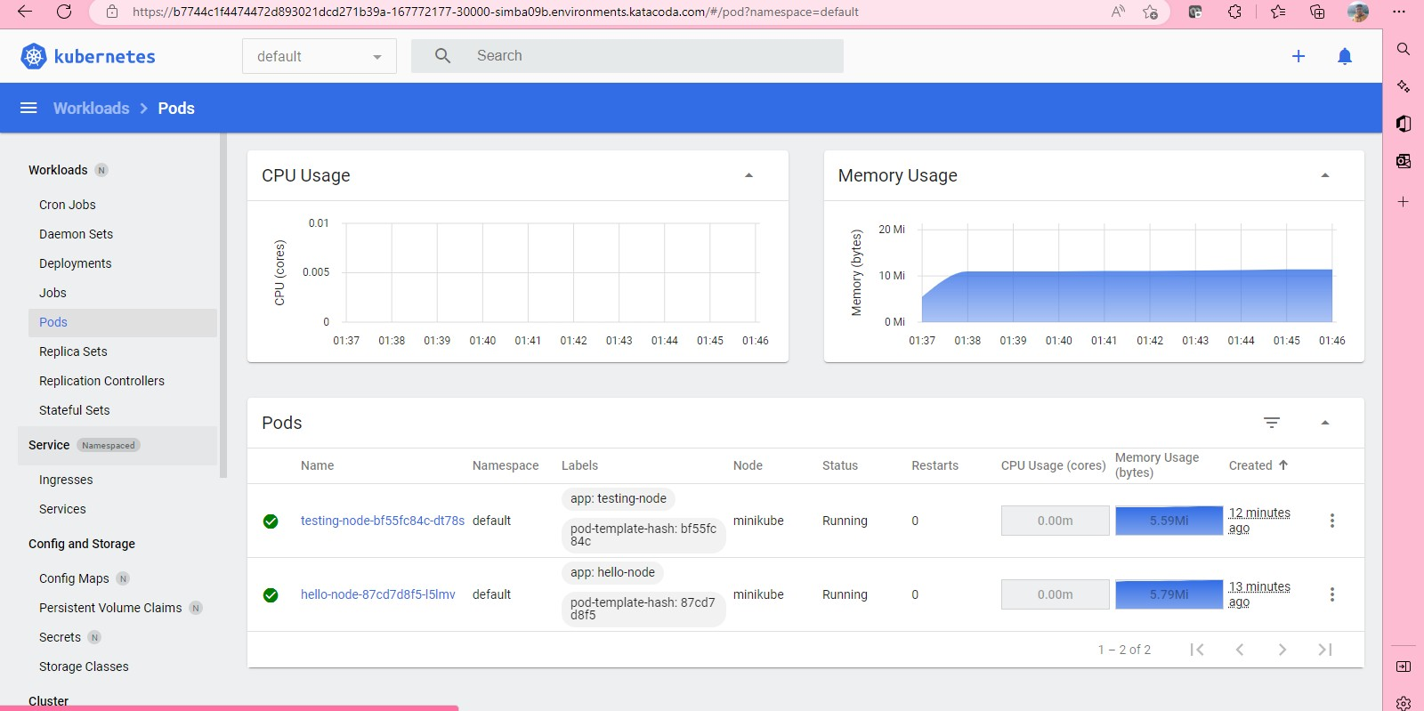

Now Cluster status:

G @ https://b7744c1f4474472d893021dcd271b39a-167772177-30000—simba09b.environments.katacoda.com/é/cl uster?namespace=default

kubernetes

Workloads n Cron Jobs

defauIt • Q Search + *

Cluster Role Bindings ==



Daemon Sets Deployments Jobs

Pods

Replica Sets Replication Controllers Stateful Sets

Service n

lngresses Services

Config and Storage

Config Maps u

Persistent Volume Claims u

Name

kubernetes-dashboard storage-provisioner kubeadm:jet-nodes

kubeadm: node-autoapprove-bootstrap kubeadm: node-autoapprove-certificate-rotation kubeadm: node-proxies

system:coredns minikube-rbac

kubeadm: kubelet-bootstrap

Created 1’

16 minutes ago ;

16 minutes ago ;

16 minutes ago ;

16 minutes ago ;

16 minutes ago ;

16 minutes ago ;

16 minutes ago ;

16 minutes ago ;

16 minutes ago ;

Secrets u Storage Classes

Cluster

cluster-admi iJ

16 minutes ago



'I — 'I 0 gif 30 

@

kubernetes

worklaads o

Cron Jobs Daemon Sete Deploymerrts Jobs

Pods Replica Sets

default • @ Search + m

Workload Status

Workloads

Replication Controllers Stateful Sets

lngresses

Deployments

Deployments

Pods

Replica Sets



Config and Sfixage

Config Maps u

Persistent Volume Claims n Secrets u

Storage Classes

**Cluster**

Name testing-node hello-node

Pods

Namespace default

default

Labels

app: testing-node

app: hello-node

Pods 1 / 1

1 / 1

Created 1’

1. mlnutes ago
2. mlnutes ago

Images

registry.k8s.io/e2e-test-images/agn host:2.39

registry.k8s.io/e2e-test-images/agn host:2.39

